**PYTHON ASSIGNMENT – 3**

**Q1. ● Find the Armstrong Number between the two numbers which are input by user**

**○ Armstrong number : 153 -> 1*1*1 + 5*5*5 + 3*3*3**

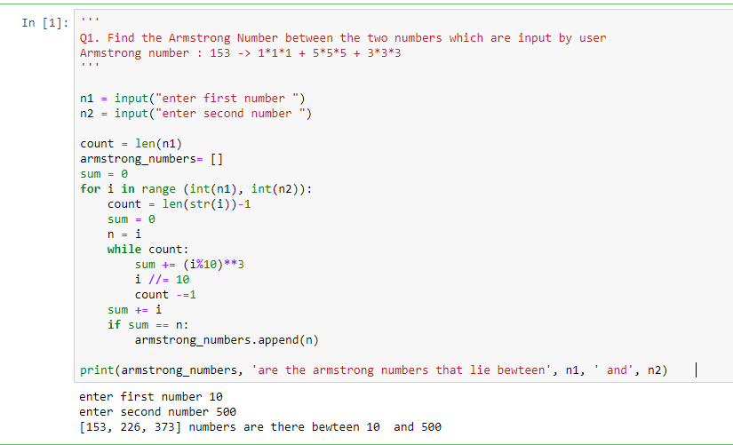

**Q2. ● Let’s say you have a string “hello this world @2020!!! ”**

**○ Remove the punctuation like [“@!#$%&*()”] from the string**

**■ Final output should be without the punctuation**

**● “hello this world 2020”**

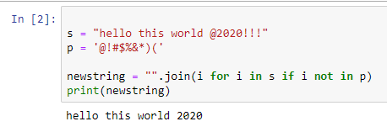

**Q3.** **You have a list with words - [“Apple”, “banana”, “cat”, “REGEX”,”apple”]**

**○ Sort words in Alphabetical order**

**■ If you get output, like [Apple, apple, banana]**

**● How has it happened?**

